M3_Car_Wiper_System

**High Level Requirements:**

Because of the Windshield Wiper system is a basic and mandatory need of any type of vehicle so this device of important part of vehicle can be used in

:-[wagons](https://en.wikipedia.org/wiki/Wagon), [motor vehicles](https://en.wikipedia.org/wiki/Motor_vehicle) ([motorcycles](https://en.wikipedia.org/wiki/Motorcycle), [cars](https://en.wikipedia.org/wiki/Car), [trucks](https://en.wikipedia.org/wiki/Truck), [buses](https://en.wikipedia.org/wiki/Bus)), [railed vehicles](https://en.wikipedia.org/wiki/Railed_vehicle) ([trains](https://en.wikipedia.org/wiki/Train), [trams](https://en.wikipedia.org/wiki/Tram)), [watercraft](https://en.wikipedia.org/wiki/Watercraft) ([ships](https://en.wikipedia.org/wiki/Ship), [boats](https://en.wikipedia.org/wiki/Boat), [underwater vehicles](https://en.wikipedia.org/wiki/Underwater_vehicle)), [amphibious vehicles](https://en.wikipedia.org/wiki/Amphibious_vehicle) ([screw-propelled vehicles](https://en.wikipedia.org/wiki/Screw-propelled_vehicle), [hovercraft](https://en.wikipedia.org/wiki/Hovercraft)), [aircraft](https://en.wikipedia.org/wiki/Aircraft) ([airplanes](https://en.wikipedia.org/wiki/Airplane), [helicopters](https://en.wikipedia.org/wiki/Helicopter), [aerostats](https://en.wikipedia.org/wiki/Aerostat)) and [spacecraft](https://en.wikipedia.org/wiki/Spacecraft).

Motor Vehicles:-

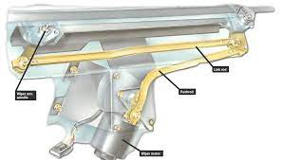

Since Motor Vehicles are the one there Wiper Systems Are mainly used so There so many many varities occurs such as

* typical link type wiper system
* Wiper Motor Permanent-magnet Type:-
* Typical wiper motor .
* Automated Type Wiper Syetem:-

Nowadays Lots of companies are trying to install automated or latest version of wind shield in there car but some of the wind shield are really expensive so many companies have no choice other that installing the semi auto wind shield in there vehicles.

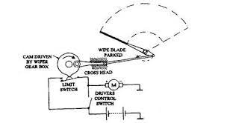

[**Watercraft**](https://en.wikipedia.org/wiki/Watercraft)**(**[**ships**](https://en.wikipedia.org/wiki/Ship)**,**[**boats**](https://en.wikipedia.org/wiki/Boat)**,**[**underwater vehicles**](https://en.wikipedia.org/wiki/Underwater_vehicle)**):-**

Water crafts is also make its place in the mostly number of using in the windshield and also in the sea there are wind speed 33–42 m/s to 58–70 m/s so there are need of wind shield work as to stop wind and water more than the removing dust. Also in ocean area These wiper systems are mostly used because there ice take palce in there glasses and to remove them from outside.

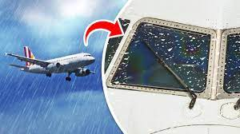

[**Aircraft**](https://en.wikipedia.org/wiki/Aircraft)**(**[**airplanes**](https://en.wikipedia.org/wiki/Airplane)**,**[**helicopters**](https://en.wikipedia.org/wiki/Helicopter)**,**[**aerostats**](https://en.wikipedia.org/wiki/Aerostat)**):-**

Unlike cabin windows, the flight deck windshields are made with glass-faced acrylic — an outer layer of glass bonded to stretched acrylic. Then, there’s a layer between them, made of urethane. Each has anti-ice and anti-fog systems. In the case of the Boeing 787, there are then layers of stretched acrylic, just like the cabin windows, albeit much thicker — between one and three inches thick depending on the aircraft.

Cockpit windshield on the Boeing 787. Image courtesy of PPG.

In some cases, such as the Boeing 737 and Boeing 747, the windshield features two plies of tempered (i.e. hardened) glass along with an interlayer. This design is likely a throwback to the originally-approved designs, with the Boeing 787 sporting a lighter version with an outside, tempered glass ply.

Cockpit windshield on the Boeing 747. It’s thicker and heavier than the 787 windshield. Image courtesy PPG.

The cockpit windshields sometimes look like they have oil on them? That oily sheen is actually a coating of indium tin oxide, which is a conductive material between the layers and transmits heat. Accordingly, this thin coating is all that is needed to keep the windows nice and clear in frosty weather. Brilliant.

Is that a splotch of oil causing the rainbow? No—its a thin coating of indium tin oxide, which is electrically conducive and transmits heat to keep the windshield clear on this Lufthansa A321. (Photo by Nicolas Economou/NurPhoto via Getty Images)

According to PPG, in the past “this was accomplished with thin wires of a design similar to those in rear car windows, but the main manufacturers now use a coating of indium tin oxide. Just nanometers thick, this coating sits between glass plies and is completely transparent.”

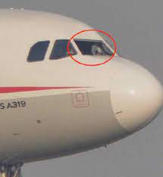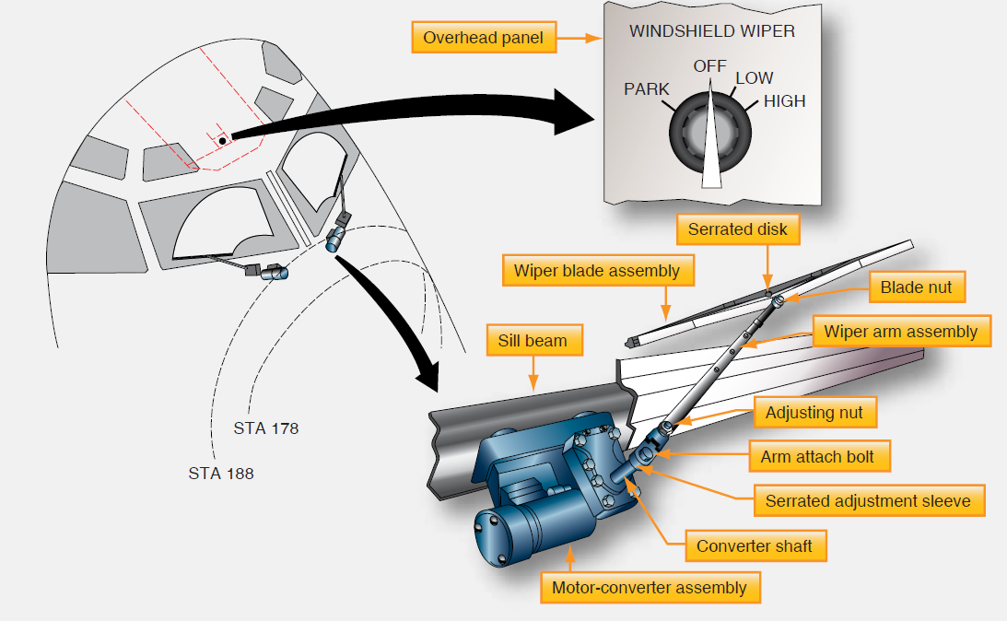

**What About Bird Strikes?**

Bird strikes are a cause for concern for pilots, airlines and manufacturers. Accordingly, flight deck windows are rigorously tested by the manufacturers. Federal regulations in the US require the window panes “withstand, without penetration, the impact of a four-pound bird when the velocity of the airplane” is equal to around 340 knots indicated airspeed in the case of a 737. (That is quite fast.)

Below, you’ll find a video of a birdstrike on a cockpit windshield which occurred less than 100 feet off the ground, just prior to landing. As you can see, this startled the first officer. The bird makes a solid thwack against the windshield but the aircraft goes on its merry way. Not so the bird, sadly.

**Low level recuirements:**

Here we came to technical aspects form device and to see how and what this device and perform

### ADVANTAGES

*Designed to rotate 180° compared to the 360° operation of a conventional motor, the action of the 'Reversing' motor reduces the travel of the wiper linkage and releases space in the plenum area. Electronic control of the wiper motor offers new features such as 'Special Park', automatic wiping angle control, speed control, obstacle detection.*  
  
  
**- Reduced space occupancy in the plenum area**  
**- Reduced weight of the motor**  
**- Reduced size of the motor**  
**- Only 3 wires to the motor (plus, minus and LIN)**  
**- 'Special Park' - automatic electronic control actuates this mode when the wipers are not in use**  
**- Enhanced car styling**  
**- Wipe angle correction - automatically delivers optimal wiping performance irrespective of windshield conditions (dry, damp, etc.)**  
**- Electronic speed control - reduced noise at blade reversal points**  
**- Obstacle detection - motor automatically compensates for windshield obstructions, such as snow block, and recalculates the appropriate wipe angle, limiting potential damage to the motor**  
  
**- Optimal wiping performance - in all windshield and weather conditions**  
**- Improved visibility - 'Special Park' mode is less obstrusive and improves driver forward vision**  
**- Improved pedestrian protection - 'Special Park' mode improves protection of the pedestrian**  
**- Enhanced driver comfort - reduced noise from wiper operation**  
**- Vehicle design freedom - space occupancy in plenum area significantly reduced**  
**- Wiper arm/blade protection - from potential sources of damage e.g. snow block.**  
**- Easy blade replacement -'service' position facilitates blade replacement**

It’s frustrating when the rain pours down and you discover that your windscreen wipers just aren’t up to the challenge – leaving you with blurry vision or irritating noises to deal with. From patches to smears, wipers that will not turn off or squeaky windshield wipers after replacement, find out common wiper problems and how to sort them.

1. My wipers don’t wash some areas

If your wipers miss patches, it might be because the wiper blade linkage is damaged or the pressure of the windshield wiper has decreased. You should change your wiper blades for a good quality brand which delivers good blade-to-surface pressure across the design. Wipers are a safety item, so it’s worth investing in a suitable set which clear the windscreen evenly.

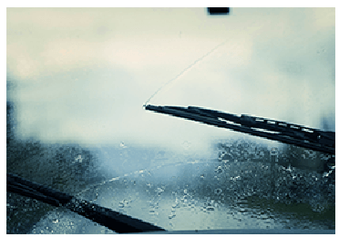

2. My wipers are slow

When windshield wipers are slow, it may be caused by a problem with the wiper motor. Sometimes the mechanical components inside the motor are clogged and it can impact the motor speed. If you experience this, you should contact a garage as soon as possible. They can then check the wiper motor and other components that may be causing the problem.

3. My wipers make streaks

If your wipers are making streaks, it’s probably due to a deformed wiper rubber, a worn linkage or wiper arm. Wipers that have high-grade rubber element are best able to deliver streak-free performance. You should change your wiper blades for a good quality option.

4. My wipers are squeaking or juddering

If you’re experiencing the annoying problem of noisy wipers, there are a few things you can try. Some oil, wax, dirt or grease on your windshield may be preventing the blade from properly wiping the water. Clean the windshield thoroughly with soapy water and glass cleaner, and also clean the wipers with alcohol wipers or alcohol solution on a paper towel.

If this doesn’t get rid of the noise, then you may need to adjust the position of the wiper blades to make sure they’re not gripping too tightly and are able to glide freely.

5. My windshield wipers will not work

If the windshield wipers don’t move at all, it’s probably an electrical problem. Sometimes it means that a fuse has blown. But a fuse will only burn out if there is an overload of power. You should contact a mechanic to check the cause of the electrical issue and fix it quickly to avoid any further damage to other components of your vehicle.

6. My windshield wipers will not turn off

If your wipers will not shut off, it’s probably a malfunctioning of the steering column control switch or the relay unit, or the rain sensor (if fitted). The switch & relay are responsible for breaking the electrical circuit to the wiper motor, so if either one malfunctions, the wipers will not stop when you turn the switch off. You need to have the electics checked professionaly to diagnose and then fix the issue.